OFFICIAL COORDINATION REQUEST FOR
NON-ROUTINE OPERATIONS AND MAINTENANCE

COORDINATION DATE- 05 May 2011
PROJECT- Bonneville Lock and Dam – Washington Shore Fish Ladder
RESPONSE DATE- 12 May 2011 (FPOM meeting)

Description of the problem- The Corps of Engineers is designing a prototype adult Pacific lamprey passage structure designed to improve lamprey passage at the Bonneville WA Shore north downstream entrance (NDE). Construction is scheduled to be completed during the 2012-2013 in-water-work (IWW) period. The structure described in the final Plans & Specifications shared with FFDRWG in 2010 consists of a system of steel flumes, water supply pipes, two pumps, pump screens and cleaners, and support structures (Figure 1 below). To eliminate the need for the tailrace pump system, the design team for this project is currently working on an alternative water supply system that is gravity fed. Most of the system will be placed along the tailrace side of the south wall, between NDE and the north upstream entrance (NUE). Construction requires 3 operational changes:

- Construction of this structure requires work outside the normal 2012-2013 IWW period of 1 December through 28 February. Currently, actual installation of the lamprey flumes and water supply system is not scheduled to begin until 1 December, but an additional three weeks of ladder outage is needed to prepare for installation. In order to complete installation of the prototype lamprey passage structure, we are requesting an extension of the IWW period to 12 November through 28 February. The Corps is aware of the need to minimize an outage of this ladder during the spring, when salmon and lamprey are vulnerable to predation by sea lions. The requested November start date is intended to avoid a March outage of the ladder.

- Powerhouse priority during the proposed IWW period (12 November – 28 February) must shift from Powerhouse 2 to Powerhouse 1.

- Installation of the proposed gravity flow water supply system requires dewatering of the Powerhouse 2 Downstream Migrant Channel (DSM2) during the requested extended IWW period (12 November start). Normal operation of the DSM2 is March 1 – December 15, so this would shorten the duration of operation of the juvenile bypass system. Submersible Traveling Screens (STS) at Powerhouse 2 would be pulled prior to dewatering of the DSM2 to prevent juvenile salmon impacts. These screens and the DSM2 would be OOS for the duration of the IWW period. Clearance and fish salvage time needed for taking the DSM2 out of service is 1 day. Removal of STSs takes 3.5 days.

Type of outage required- 1) Ladder outage outside normal IWW period; 2) Powerhouse priority shift; 3) Early closure of B2 juvenile bypass facilities.

Impact on facility operation- Early closure of the WA Shore Fish Ladder and the B2 juvenile bypass system requires assessment of impact on upstream and downstream fish passage. Early closure of DSM2 (FPP juvenile bypass system maintenance period is December 16 – February 28) requires closure of B2 juvenile bypass system, including removal of STSs.

Length of time for repairs- 12 November 2012 to 28 February 2013

Expected impacts on fish passage- There will likely be little impact to ESA-listed adult and juvenile salmonids during the proposed extension period and little to no impact on Pacific lamprey.

- Adult Salmonid Passage

Steelhead migration is the most important activity during the proposed outage extension of mid to late-November, with Chinook and Coho passage declining to minimal levels by the end of the month. Switching to B1 priority should alleviate most delay impacts on adult salmon and steelhead. Although spillway fallback of Bradford Island Fish Ladder-passed salmon and steelhead is of concern during summer spill operations, there is relatively low fallback risk during the proposed 12 November – 28 February work window, when spill will generally be limited to Spillbay 18 (for adult attraction).

From 15 November to 1 December:
In 2009, 125 Chinook salmon passed BON, with counts descending to fewer than 4 fish per day by 25 November. In total, 597 steelhead passed BON in 2009, averaging 35 fish per day during this period. In some years, steelhead passage from mid-November through 1 December can be substantial. In 2007, 2444 steelhead were counted at BON during this period. In 2009, 325 coho passed the dam, with counts dropping to fewer than 10 fish per day by November 25. Chum salmon pass BON in low numbers in November. Pacific lamprey passage is typically minimal this late in the year, ranging from -4 to 4 since 2005.

From 1 December through February 28:
There is very little salmon passage activity at Bonneville dam during the winter, but this outage would overlap with the winter steelhead passage season. In 2009, 2334 passed BON during this period.

- Juvenile Salmonid Passage

The juvenile migration season occurs from March 1 through November 30, though nearly all juvenile salmonids have passed Bonneville by the beginning of August. Thus, pulling STSs, shutting down the DSM2, and switching to B1 priority in mid-November should have little impact on out-migrating juvenile salmonids.

- Pacific Lamprey Passage

Adult lamprey passage at Bonneville typically peaks in June-July and declines through October, when most upstream lamprey passage activity ceases. Based on RT studies, switching to B1 priority may provide some minor benefit the few adult lamprey migrating during the proposed 12 November – 1 December operation. Impacts of this operation on juvenile lamprey are unknown.

Comments from agencies.
-----Original Message-----
From: Bob Heinith [mailto:heib@critfc.org]
Sent: Wednesday, May 11, 2011 3:04 PM
Subject: Re: FPOM: Official Coordination- WS lamprey mods early outage

Thanks Tammy. CRITFC strongly supports the lamprey passage structure work outside the in-water work period given the present failure of adult lamprey to enter this fishway and likely little impact to salmon with the first powerhouse and fishways in operation. Radio tag data indicate that a majority of all adult lamprey attempt enter the WA shores fishway (65-70%) and of these only about 40% successfully enter the ladder. The new lamprey structure should facilitate much improved passage for these adult lamprey. With total Bonneville Dam adult lamprey counts at only about 20,000 for the last two years, it is critical that this work proceed in a timely fashion as it has already been delayed two years due to contractual issues.- Bob

12 May 2011 FPOM. Meyer asked if the water supply design would be available for review. Tackley said it should be available at the 2 June 2011 FFDRWG.

Wills would like to see the fish numbers during this time period. Tackley said there are some fish passage numbers from 2009.

Fredricks is still curious about the BiOp impacts for this.

Final results- This may proceed as coordinated.

Please email or call with questions or concerns.
Sean Tackley
503-808-4751
sean.c.tackley@usace.army.mil

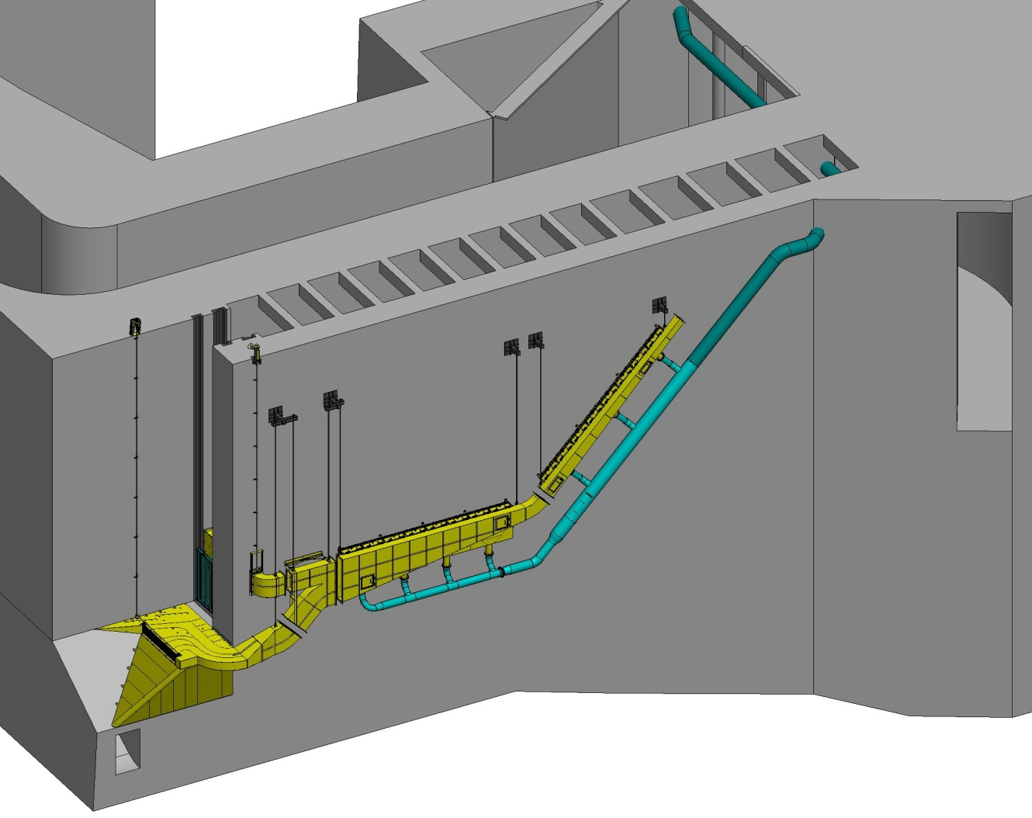

Figure 1. 3-dimensional rendering of proposed prototype lamprey passage structure with gravity flow water supply system.

